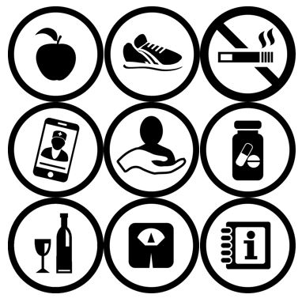
Training modules covering:

Lifestyle risk factors for NCDs
Hypertension
Diabetes
Mental health
- Depression and Anxiety
Epilepsy
Asthma
Sickle cell disease

Non-communicable diseases:

Training Modules for Primary Care
COMDIS-HSD 2018

Training Modules for Primary Care
Non-communicable diseases:
Session 1a – Introduction to NCDs 3
Session 1b – Communication skills 4
Session 2 – Hypertension 7
Session 3 – Type 2 diabetes 12
Session 4 – Depression 14
Session 5 – Respiratory disease 166
Session 6 – Sickle cell disease (SCD) 188
Session 7 – Epilepsy 19
How to use an Inhaler? 200

Session 1a – Introduction to NCDs

The learning objectives are to:

- Understand why NCDs are important.
- Recognise potential NCDs in asymptomatic patients.
- Understand basic screening tests.
- Understand the NCD care model.
- Understand the role of treatment supporters and health educators.

Summary
- NCDs are becoming important (they are no longer just a problem for the developed world).
- Remember opportunistic screening.
- Management
  - Plan and explain disease management.
  - Add to the register.
  - Complete the treatment card.
  - Give disease-specific education.
  - Give lifestyle advice.
  - Explain medication and treatment support.
  - Arrange a follow-up appointment.

Resources to take home
- Case management desk guide.
- Health educator guide.
- Links to further E-resources.

The desk guide covers much more of this training, the main emphasis today is on detecting early disease and following up on chronic disease. Having a systematic way of managing patients is key.

Exercise
Why are you here today?
What are the most common NCDs you see in your practice?

Write answers to these questions before discussing with your neighbour.

Group discussion about the use of treatment supporters and health educators.

Session 1b – Communication skills

The learning objectives are to:

- Learn how to use effective communication in identifying and caring for people with non-communicable diseases.

Summary
Effective communication is essential to good quality care. Good communication is needed to obtain information about the patient’s symptoms and deliver information about the patient’s diagnosis and care.
A patient is more likely to continue with their treatment if they understand their diagnosis, why treatment needs to be life-long, and is fully aware of the risks to their health if they stop treatment. The way these issues are discussed can directly affect how a patient acts.

Patients are often:
- Worried about the cause of their illness, how long they will have the illness, whether the illness can be cured and how it can be controlled.
- Embarrassed by any social stigma of their condition.
- Afraid or worried about confidentiality.
- Worried about the attitude of the health worker.

Everyone can improve on their communication skills, even after many years of experience. We will practise these communication skills in each of the training sessions.

See communications sheet on golden minute and communicating WELL

Practical exercise A (5 minutes)

Open and closed questions

This is a quick exercise about recognising different types of questions used in consultations and interviews. For each question listed below, decide if it is:
- An open question.
- A closed question.
- A leading question.

Note down your answers – discuss with your neighbour.

Questions:
- Tell me about your problems.
- You are no longer feeling sick with the tablets now are you?
- Tell me, how have you been since your last visit?
- You were feeling ill at the last visit, and I changed the tablet – are you feeling better now?
- You said you have had urine trouble, can you tell me more about that?
- You've had weight loss, is it for a month?
- Do you have blood when you cough?

Discuss your answers with your colleagues and the facilitator.

Share answers? Any problems with this?
Any challenges we expect from participants?

Facilitator will explain role play
Role play can increase understanding and is the best way to teach communication skills.

Example role play about an obese person with high blood pressure

Facilitator’s example of a bad consultation.
Facilitator’s example of a good consultation.
Facilitator’s example of feedback process (using Pendleton’s rules listed below) and summarise areas that worked well and areas that could be communicated differently.

Giving feedback – Pendleton’s rules

- The ‘health worker’ is always asked to give feedback first. He or she is asked to say what they did well.
- The ‘patient’ is then asked to comment on what they feel the ‘doctor’ did well.
- The ‘doctor’ is then asked to say what he or she thinks they could have done better.
- If there is an observer, he or she is asked to comment on something the ‘doctor’ did well, then offer suggestions for improvement on one aspect that went less well.
- Facilitator may offer their own comments or observations.
- Participants from other groups may be asked for additional observations.
The observer summarises at the end and may make recommendations.

10 minute break
Ask everyone to stand up, walk around and say hello to 2 people they don’t know.
Networking and sharing ideas is another benefit of this day.

Session 2 – Hypertension

The learning objectives are to:

- Understand why treatment for hypertension is advised.
- Be able to take a blood pressure, know about opportunistic screening for hypertension.
- Recognise people who require antihypertensive treatment.
- Recognise people who require referral or admission.
- Understand how to explain hypertension to patients.
- Understand the treatment options including medication and lifestyle advice.

Disease summary
Read the ‘Risk assessment for cardiovascular disease (CVD)’ section of desk guide on p10, and refer to this.

When anyone > 40 years old or overweight attends for any problem, screen for CVD.

- Check BP, weight and/or waist circumference and manage as below.

Practical exercise in groups of 3
Read ‘Taking a blood pressure reading’ below and practise taking a blood pressure reading.

Taking a blood pressure reading

If you are not checking the blood pressure yourself, ensure that whoever takes it knows how to take an accurate reading. This simple guide might be useful for them.

- It is important that the blood pressure is taken with the patient after they have been sitting for 5 minutes. Make sure you have the correct equipment:
- a stethoscope
- a sphygmomanometer (blood pressure machine)
- the correct sized blood pressure cuff
- Make sure the patient is sitting with their feet flat on the floor and their arm out at heart height, resting on a table.
- Make sure the arm cuff is properly deflated before placing it around the patient’s upper arm. If required, use a smaller or larger cuff.
- Wrap the cuff tightly around the upper arm, ensuring the whole cuff is above the elbow.
- On the same arm as the cuff, with the palm turned upwards, feel in the inside curve of the elbow on the little finger side of the elbow for the brachial pulse. Place your stethoscope over the pulse (see below).

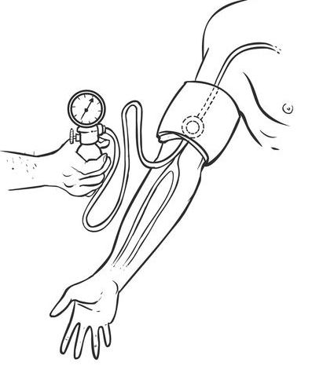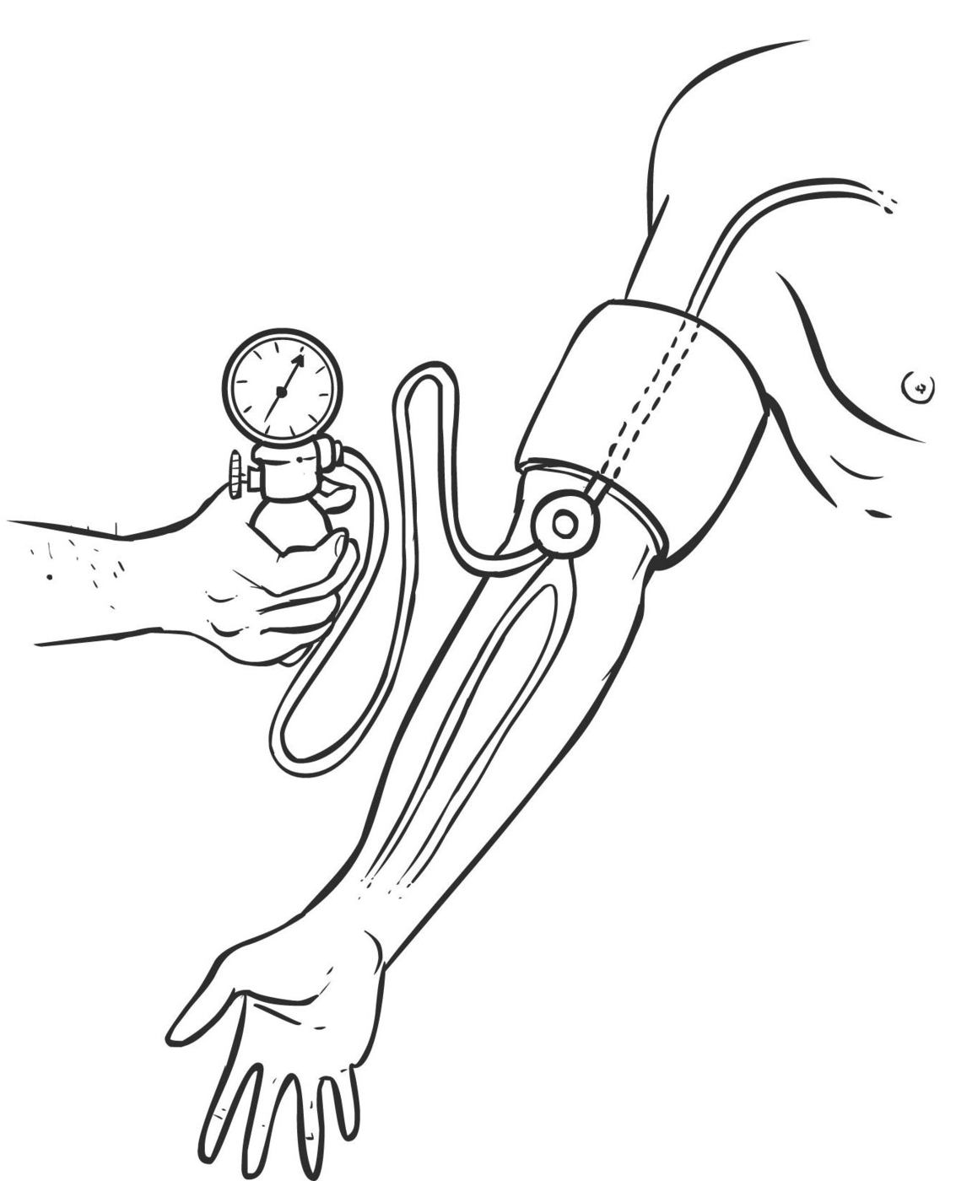

- Slowly inflate the cuff of the BP machine until you can no longer hear the blood flow through the artery.
- Now slowly deflate the cuff and listen for when the sound of the pulse returns.
- Note the value of the mmHg on the machine - this is the systolic blood pressure.
- Continue deflating the cuff until you can no longer hear the pulse.
- Note the value of mmHg on the machine – this is the diastolic blood pressure.
True
Manometer
Manometer
Stethoscope
Stethoscope
Brachial artery
Brachial artery
False

Reflect how blood pressure is checked in your health facility/practice.

Share what happens in your practice.
- Who checks?
- What happens to the result?
- Who is responsible for responding to BP results?
- Are there any changes you think would be helpful?

Read the ‘Hypertension’ section of the desk guide on p11, and refer to this.

Are there areas of hypertension diagnosis and management that are or are not done in your setting? Are there any changes you would like to make in your setting?

Role play
Instructions:
- Split into groups of 3.
- Each of you will have an opportunity to play the role of the health worker, the patient, and the observer.
- Each group will have practise consultations, which should last about 5-10 minutes each, followed by a few minutes feedback from the observer.
- When it is your turn to play the health worker, observer or patient, read the paragraph below relating to your role.

When you are:

The patient
Using the case studies on the following pages, try to play the role. Imagine how this person would think and speak, and try to act as them. Use their way of talking, expressions and concerns. Listen to what the health worker says, but also mention your concerns according to the case study notes below.

The health worker
Refer to the relevant pages of the desk guide. Keep these pages open and use them during the role play to ensure that you do not forget anything important. Look at the case study below for more information. When you are the in the health worker role, take a few minutes to recall how to communicate W.E.L.L (Welcome, Encourage, Look and Listen). Try to practise this during your consultation.

The observer
Refer to the relevant pages of the desk guide. Keep these pages open and look at them during the role play to ensure that the health worker does not forget anything important. Note down some good and “could be better” feedback to mention after the role play. Remember to be specific and constructive. Your feedback could relate to the content of the discussion or how well it was communicated, using W.E.L.L.

Role play 1

The patient: You are Moses, a 51-year-old man who has been to the clinic regularly for minor problems; you are a bit of a worrier. You have a sore arm, which has been dealt with appropriately. You are married, your mother, aged 72, is healthy but your father died a few years ago from pneumonia. You are a smoker.

The health worker: Moses’ arm is sore because of a skin infection (no need to discuss this further). During the consultation you notice that he is plump and over 50. You decide to measure his waist circumference, take his blood pressure and ask if he is a smoker. Waist: 104 cm Blood pressure 145/90 mmHg. His blood pressure isn’t so high as to medicate. Instead you offer lifestyle advice.

The observer:
Consider the following when observing the role play:

- Did the health worker explain what blood pressure was and why we treat it?
- Did the health worker follow the guidelines and advise lifestyle changes and review in 3 months?
- Any comment on the communication skills?
- Acknowledge that it can be difficult to make many lifestyle changes at one time, but emphasise how important it is for his health. Offer support and referral for health education, if appropriate.

Group feedback and discussion
- Ask participants how it went?
- Is it easy to bring up BP testing during the consultation about Moses’ arm?
- Is it easy to suggest lifestyle advice across the 5 areas of smoking, healthy eating, physical activity, weight, and reducing alcohol intake?
- Is it important to discuss the patient’s current medication?
- Can doctors/clinicians give brief education, and
- Can it be arranged for another health worker, e.g. a nurse to counsel? i.e. on the diagnosis/treatment, adherence to pills and appointments and lifestyle changes?

Role play 2 (giving medication and doing a random blood sugar)

The same scenario as role play 1, but 3 months later.
Change your role.

The patient (Moses): You are finding it difficult to stop smoking. As you work as a cook changing your eating habits has been difficult. Your mother has been diagnosed as diabetic. You are anxious that you might be too.

The health care worker: You want to find out how Moses has been over the last 3 months and what changes he has made. You also want to check his blood pressure again. What else might you do?
His blood pressure is now 160/100 mmHg. What do you do now?

Observer:
Consider the following when observing the role play:
- Did the health care worker remember their consultations skills?
- Did they ask about Moses’ worries?
- Did they follow the guidelines, did they consider random blood sugar?
- What about medication?
- Did they manage to use the 1-page summary desk guide?

Group feedback and discussion (use exercise sheet)
- (Participants) say how it went.
- Is it easy to bring up BP testing during the consultation about his arm?
- Is it easy to suggest lifestyle advice across the 5 areas of smoking, healthy eating, physical activity, weight, and reducing alcohol intake?
- Is it important to discuss family history?
- Is it important to discuss the patient’s current medication?
- Can doctors offer support?

Non-communicable disease monitoring
Doctors need to review the BP levels over time.
For example, HIV and TB are monitored and management of these diseases is successful.
There are often no records that do this for NCDs.
It has been suggested that treatment cards could help us monitor trends for NCDs.

You will be given a treatment card to fill in; use of these helps monitoring treatment.
Discuss in small groups
How would you use these?
Bring any outstanding questions to the facilitator

Session 3 – Type 2 diabetes

The learning objectives are to:

- Understand the importance of checking a random blood sugar.
- Confidently diagnose type 2 diabetes.
- Explain why treatment is required and what that might be.
- Know when referral is required.
- Understand the need for regular follow up.

Screening
A large proportion of people with raised blood glucose are not aware of this, their symptoms, if any, have come on gradually and are not mentioned. In particular, people who are over 40 years and overweight are more likely to have raised blood glucose (either at the level of prediabetes or diabetes).

Look again at the ‘Risk assessment for CVD’ section on p10 of the desk guide, where it says:
If a waist circumference >104 cm in men, >88 cm in women.
If > 7.8mmol/L (or 140mg/dl) see ‘Diabetes’ section on p13, where it says:

No symptoms in many people but ask about:
- Excessive thirst and frequent urination (rule out urinary tract infection with a urine dipstick).
- Unexplained weight loss (N.B. also counsel and test for HIV).
- Weakness, tiredness.
- Recurrent infections (e.g. boils or itchy vulva +/- dysuria [vaginal thrush]).
- Pins and needles sensation in feet.

Discuss, in your groups of 3, how to do opportunistic screening of people. How do you ensure those over 40 years who are overweight, or weak/tired, or have recurrent infections (or have specific symptoms such as thirst, frequent urination etc.) have a random blood glucose taken? If blood glucose is high, how can you ensure they return next morning (drinking only water) for a fasting blood glucose to diagnose diabetes?
Work in threes
Consider: your patient is a 54-year-old male who presents in clinic with thirst, polyuria and increasing tiredness (as patient turns up the following measurements are likely to be a random blood sugar rather than a set appointment to do a fasting blood sugar test).

- What test would you do?
- The reading is 16.2 mmol/L, what would you do next?
- If the reading had been 8.6 mmol/L, what will you tell the patient?

Discuss the details. When do you diagnose diabetes? Does your clinic measure Hba1c? Discuss the measurements.

Role play
Aim: to practise explaining diabetes to patients and possibility of medication.

The patient: You are the patient in the above exercise and have just been given a diagnosis of type 2 diabetes. You are 54 years old, married, with four healthy, grown-up children. You are overweight, take little exercise and are a smoker. You work as a driver. You know very little about diabetes and need the doctor to tell you about your diagnosis.

The health worker: Using the desk guide, explain diabetes, that it needs lifelong treatment, and that it has serious complications if not treated adequately. You then need to go on to discuss treatment, initially lifestyle changes, but also follow up and possible medication. Ask them to bring a family member (treatment supporter) to the next appointment. At all stages you must give the patient opportunity to ask questions and to ask for further explanation, if needed.

The observer: Were the explanations and advice given adequate and in a form that was understandable to someone with no knowledge of diabetes? Was the patient made aware of the need for follow up and clear about what that would be? Were good communication skills demonstrated? Do you think that the patient has shown that sufficient information has been understood to proceed?

Also ask and discuss in the group where you would refer a patient with diabetes, who has complications such as reduced vision.

Session 4 – Depression

The learning objectives are to:

- Confidently diagnose depression.
- Understand how common and important it is.
- Know how to recognise suicidal ideas.
- Understand when medication is appropriate and what other actions to take.

Disease summary
Read through the ‘Mental health’ section of the desk guide on p15 and refer to the depression section in particular.

Practical exercise

Using the depression summary, work in pairs and identify areas of diagnosis and management that are and are not practised in your setting.

Consider the case below:

Your patient is a 54-year-old male who you see to review his diabetes but he looks sad and worried. You ask him the routine depression screening questions.
Have you lost interest in doing things?
Have you felt down depressed or helpless?
He answers yes to both
What other questions would you ask?

Role play 1 (20 minutes)

The patient: You are the patient in the above exercise. You are 54 years old, have had type 2 diabetes for 3 years, and are married with 3 children. You have not lost anyone close recently, you are not wealthy, but you have no money worries. Lately you have been worrying about lots of things. You don’t enjoy what you used to. You have not thought of harming yourself. You don’t sleep well. You find that when you are working you don’t concentrate and make mistakes, you feel tired.

The health worker: Using the desk guide ask about depression; assess the severity. Explain to the patient about depression and suggest a plan.

The observer: Were the explanations and advice given adequate and in a form that was understandable to someone with no knowledge of depression? Was the patient made aware of the need for follow up and clear about what that would be? Were good communication skills demonstrated? Do you think the patient has shown sufficient information has been understood to proceed?

Role play 2 (20 minutes)

The same scenario as role play 1, but 3 weeks later.

The patient: The patient has returned, brought in by his wife. She is worried that he now wants to kill himself.

The health worker: Using the desk guide, assess the severity. Suggest a plan.

The observer: Was the advice well presented, and did the patient understand it? Was the patient given opportunity to ask questions? Were good communication skills demonstrated and was the written material well used?

Group discussion in groups of 6 (joining two groups of 3).
10 minutes.
Any questions/problems you anticipate?

Review the guides for when to refer

Is that practical in your setting?

Write down an answer and share with the large group.

Session 5 – Respiratory disease

The learning objectives are to:

- Assess chest signs and symptoms to make a diagnosis.
- Identify serious illness that needs immediate treatment or referral.
- Use a peak flow meter and explain how to use it to a patient.
- Use an inhaler and spacer and explain how to use it to a patient.
- Give appropriate advice and medication.

Disease summary
Read through the ‘Asthma and COPD’ section of the desk guide on p21, and refer to this.

Exercise in groups of 3
Common chest problems
Discuss common chest problems and current treatments in your setting. Do you all see the same type of problem and manage in the same way, if not why not?

Peak flow and inhalers
Practical exercise (5 minutes)

In your groups:

Group 1 – Refer to the ‘How to use a peak flow meter’ section at the end of this document to check your own peak flow rate and check against the chart for what is normal for your age and height (normal without symptoms may be 80%-120% of predicted).
Then practise explaining how to record a PEFR to each other.

Group 2 – Refer to the ‘How to use an inhaler’ section at the end of this document.
Practise using an inhaler correctly.
Then practise explaining how to use this to each other.

Groups swap activities.

Role play for asthma
Aim: to identify the patient who requires emergency treatment during a severe asthma attack.
N.B. The health worker can ask the observer for details of the patient’s clinical information.
See section of the NCD management desk guide titled ‘Severe asthma’.

The patient: You are Annette, an 18-year-old girl who has never been to the clinic before.
You have had recurrent dry cough and chest tightness for a long time.
You have now developed difficulty in breathing, which is worse early in the morning and at night time.

The health worker: You are seeing Annette for the first time in the clinic.
As she walks into the clinic you hear her wheezing.
As you talk to her, you notice she is unable to complete sentences.

The observer: The health worker should ask Annette about her difficulty in breathing and other symptoms and make an assessment as to whether she needs urgent referral. If the health worker asks to examine the patient tell them the following results: RR= 38, with widespread wheeze bilaterally.

Role play 2, asthma follow up
Aim: to understand the role of follow up in asthma
N.B. The health worker can ask the observer for details of the patient’s clinical information.

The patient: You come back to the clinic 2 weeks later, after being in hospital for 3 days. You were given oral steroids and a salbutamol inhaler. You feel much better. You are now taking your inhaler when you needs it: 5-6 times daily. You still wake most nights. You are breathing normally when seen and can speak in sentences

The health worker: Look at the guide and assess the level of symptoms, and if a step up or down in treatment is needed.

The observer: The health worker should ask about sleeping, daytime wheeze etc. as listed in desk guide.
If the health worker asks to examine the patient, tell them the following results: chest has slight wheeze, respiratory rate is 14. PEFR is 350 (check on the chart in the desk guide whether this is normal for an 18-year-old who is 170 cm tall).

Session 6 – Sickle cell disease (SCD)

The learning objectives are to:

- Understand the inheritance of sickle cell disease.
- Recognise the signs and symptoms of sickle cell disease.
- Know how to diagnose sickle cell disease.
- Realise when to refer to hospital.
- Understand about measures to reduce complications and crisis.
- Know how to educate patient and family on prevention and early warning signs.

Disease summary
Read through the ‘Hypertension’ section of the desk guide on p11. Identify areas of diagnosis and management that are and are not practised in your setting, discuss.

Role play
Aim: to take the child’s history and to think about diagnosis of child’s symptoms and consider if urgent treatment is needed. Also, the health worker should communicate concern without alarming the father.

N.B. The health worker can ask the observer for details of the patient’s clinical information.

The patient: You are the father of Amel, a 6-year-old boy who has been to the clinic several times. He has been sickly from childhood and now has a fever, with painful bones and joints.
You are worried because you have lost a child with similar complaints before.

The health worker: You are seeing a child in pain, crying inconsolably. You notice that he has yellow eyes and he is small for his age. You will need to examine the patient for critical illness and decide whether they need urgent referral. Use the desk guide one-page summary for SCD.

The observer: The health worker should ask about joint and bone pains and other symptoms, and make an assessment as to whether he needs urgent referral.
If the health worker asks to examine the patient, tell them the following results:
Patient’s Hb= 3.2 g/dl, T= 39ºC.
Do they explain to the father what is happening? Do they follow the guidelines about referral?

Group discussion

Consider: You see Amel and his father 3 weeks later. Amel is out of hospital and the family wants advice about how to look after him.

What would you discuss with the family about sickle cell disease?
Practise using some of the phrases you might use to explain this complicated problem to someone who doesn’t know anything about blood cells.

Session 7 – Epilepsy

The learning objectives are to:

- Differentiate between a fit and a faint.
- Know the treatment options and how to choose.
- Place someone in the recovery position and explain it to others.
- Explain epilepsy and its treatment to patients.

Disease summary
Look at the ‘Epilepsy’ section of the desk guide on p19, and refer to this. Identify areas of diagnosis and management that are and are not practised in your setting.
Discussion in groups of 3
Consider: Rita is 23 years old, she collapsed recently and has been told she lost consciousness. She is concerned that she had a fit and is possessed by the devil.

Go through the summary on epilepsy and use the check list at the top of the page to differentiate between a fit and a faint.

What questions could you ask to decide this?

You are told that it was a very hot day, she had not had anything to eat that day, and she had not had any shaking, nor been incontinent

What do you think may be the problem/diagnosis?
What about any underlying factors?

Practise explaining your diagnosis to Rita.

Role play
Aim: to be sensitive when talking to the patient about their epilepsy – which is a stigmatised disease – to make them feel at ease, and identify epilepsy medications suitable for HIV patients.

N.B. The health worker can ask the observer for details of the patient’s clinical information.

The patient: You are Akan, a 27-year-old man who has come to the clinic as you have heard there is a new treatment for fits. You have had fits from childhood and people are very wary of you, so you have no job and life is very difficult. You have never had any treatment for fits. You have HIV but are taking your treatment and feel physically well.

The health worker: You are seeing a young man who looks anxious and thin. You use your communication skills to set him at ease and ask about the problem. Start your consultation using the desk guide.

The observer: The health worker should ask about the fits, timing, recovery and other symptoms. They should also ask about other illnesses and medication. Do they explain to the patient what is happening? Do they follow the guidelines about treatment?

How to use an inhaler?

Using an inhaler is the most common way of taking asthma and COPD medicines.

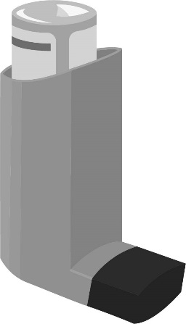
Show and check how to use an inhaler both in the initial consultation and also in subsequent consultations.

Explain the following 8 steps to the patient for proper use of inhaler:
- Remove cap and hold inhaler upright then shake well.
- Breathe out gently and put mouthpiece between teeth without biting.
- Breathe in slowly through mouth and press down firmly on canister.
- Continue to breathe in slowly and then hold breath for about 10 seconds.
- While holding breath, remove inhaler from mouth.
- Breathe out gently away from mouthpiece.
- If an extra dose is needed, wait 1 minute and repeat steps 2 to 6.
- Replace cap.

How to use a peak flow meter
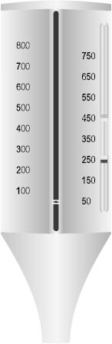
- Move the marker to the bottom of the numbered scale.
- Stand up straight.
- Take a deep breath. Fill your lungs all the way.
- Hold your breath while you place the mouthpiece in your mouth, between your teeth. Close your lips around it. DO NOT put your tongue against or inside the hole.
- Blow out as hard and fast as you can in a single blow. Your first burst of air is the most important. Blowing for a longer time will not affect your result.
- Write down the number you get. But, if you coughed or did not do the steps right, do not write down the number. Instead, do the steps over again.
- Move the marker back to the bottom and repeat all these steps 2 more times. The highest of the 3 numbers is your peak flow number. Write it down.

