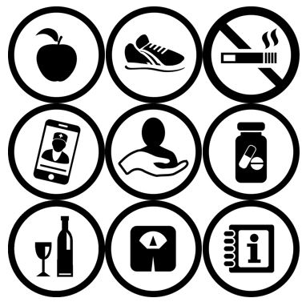
Adherence, treatment support and information about non-communicable diseases (NCDs):

Lifestyle risk factors for NCDs
Hypertension
Diabetes
Mental health
- Depression and Anxiety
Epilepsy
Asthma
Sickle cell disease

Non-communicable diseases:

Lifestyle and Health Education
Desk Guide
for Primary Care
COMDIS-HSD 2018

Foreword

This is a ‘quick reference’ desk guide for healthcare workers involved in educating patients on non-communicable diseases (NCDs). These healthcare professionals may include doctors, nurses and health educators. The guide contains information to help change behaviours related to NCDs, including treatment support, adherence to clinic appointments, medication and key lifestyle risk factors of adults at risk of NCDs and other related conditions.
The general principles of patient support and adherence apply to many NCDs, hence the use of this guide is recommended for patients with cardiovascular disease (CVD), such as angina, strokes and heart attacks and risk factors, such as hypertension and diabetes mellitus type 2, as well as mental health conditions, epilepsy, sickle cell disease and respiratory conditions, such as asthma and chronic obstructive pulmonary disease (COPD).
This guide should be used in health service settings as part of a package of tools, including the ‘NCD Diagnosis and Treatment Desk Guide’ for doctors and other clinicians.
This guide can also be used with suitable lifestyle education leaflets.
This guide incorporates the best current evidence and recommendations but is not comprehensive. Users should be aware that all decisions remain with the doctor, nurses and health educators using them.
Prepared by Prof John Walley, Dr Kirstie Graham, Dr Jessica Sales, Dr Cath Snape, Laura Bates, Dr Nina Putnis and colleagues of COMDIS-HSD (Nuffield Centre for International Health and Development, University of Leeds, UK); Dr Ann Akiteng (formally of Uganda Ministry of Health); Dr Benard Bene (NCD Division, FMoH, Nigeria); Prof Olayinka Omigbodun (Psychiatrist, College of Medicine, University of Ibadan) and Dr Akan Otu (University of Calabar Teaching Hospital).
It has been adapted for Sierra Leone by members of the national/Bombale district Technical Working Group and the Royal College of General Practitioners, UK.
The materials in this package are free to use but cannot be reproduced for sale. This work is licensed under a Creative Commons Attribution-NonCommercial-ShareAlike 4.0 International License.
Comments and proposed edits are welcome to Professor John Walley: j.walley@leeds.ac.uk

Table of contents

How to use this guide 4
Section 1: Patient support and adherence 5
Section 2: Lifestyle assessment and advice 8
Smoking 11
Weight 12
Healthy eating 13
Physical activity 15
Reducing alcohol intake 16
Section 3: Counselling on patient’s medical condition 17
Hypertension 18
Diabetes 19
Depression and/or Anxiety 21
Epilepsy 23
Asthma 24
Sickle cell disease 27

How to use this guide

A patient will be referred to you following initial assessment, diagnosis and management by a doctor, nurse practitioner or other clinician. The healthcare worker should briefly discuss with the patient the key messages related to lifestyle change, disease education, adherence to clinic appointments and medication. This guide can then be used by you as an additional tool to support the patient through what is frequently the life-long management of their condition.

This guide is divided into 3 sections:

- Patient support and adherence
- Lifestyle assessment and advice
- Counselling on the patient’s medical condition

This guide will help you deliver key educational messages and develop action plans with the patient. Discuss each section of the guide with the patient and their treatment supporter.

Use education leaflets (where available) as a prompt.

Help the patient make their own action plan. Review progress at each appointment, encourage all efforts to change behaviour, re-emphasise key messages and discuss whether the patient is ready to target other behaviours. If they are ready, give the patient the necessary help and guidance. Review all individual goals and revise them to reflect the patient’s progress.

Always make a follow-up appointment.

Section 1: Patient support and adherence

Use an education leaflet (if available) as a prompt.

Explain to the patient the importance of attending clinic appointments and taking prescribed medication.

Discuss the importance of a treatment supporter.

Tell the patient that if they miss an appointment a reminder will be sent or an attempt to contact them will be made.

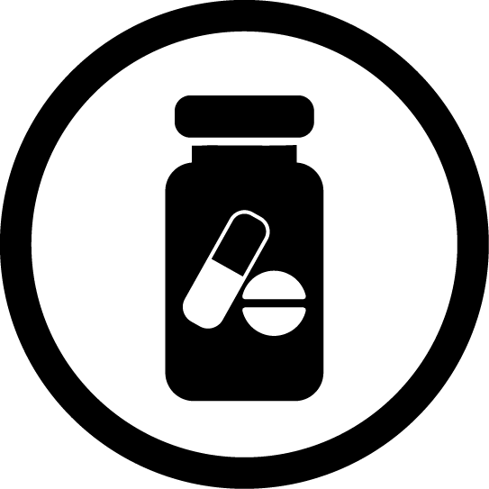
Give information on healthy lifestyles and disease-specific advice.

Education on medication

Give education on medications and adherence, including:
- The importance of lifestyle changes to accompany medications.
- Name and dosage of each tablet.
- To take tablets as prescribed, at the same time each day.
- Not to take someone else's tablets.
- If they forget to take a tablet, not to take an extra dose next time, instead carry on as normal after the missed dose.
- Only change tablets when the doctor advises them.
- Tell the doctor if they experience any side effects.

A treatment supporter

Explain to patient why a treatment supporter is important:
- A treatment supporter is someone who is accessible, and they can talk to easily; someone who will encourage them through the treatment process.
- Treatment is life-long, support is essential.
- It can be difficult to remember to take tablets regularly, but it is vital to continue treatment.
- It is their choice who will be their treatment supporter. The treatment supporter will be called if the patient cannot be contacted or if there is a problem. It is desirable that the same person attends the follow-up appointments with the patient.
Discuss who would be the best treatment supporter; it must be someone concerned, trusted and committed to providing support.

Help the patient choose someone, e.g. family member, friend or community volunteer. If patient cannot decide then suggest someone. It would be helpful if this could be someone who has had similar problems and has successfully changed their behaviour.
Record name, address and mobile phone number of patient and treatment supporter on the patient’s treatment card.

Ask the patient to bring treatment supporter with them for all clinic visits, to learn about the illness, treatment and their role.

Advise the treatment supporter to:
- Meet with the patient often, try to make this an enjoyable time. If possible, meet at the time the patient takes their tablets to see them taking the tablets as prescribed.
- Look at tablet pack to check the patient is taking tablets correctly.
- Inform health worker if the patient stops taking the tablets.
- Encourage the patient to be active, eat healthily, stop smoking as needed and attend all appointments.
- If this is someone with similar experiences they can demonstrate how they changed their behaviour or overcame any difficulties.

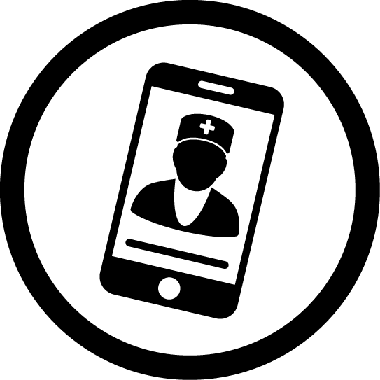
Appointment reminders

If an individual fails to attend a review appointment, take action:
- Phone the patient and encourage them to return.
- Phone the treatment supporter and ask them to remind the patient.
- Send reminder letter to the patient if you cannot contact them.
- Ask someone (e.g. ask community health worker to home visit if patient does not return).
If patient is not adhering to treatment or attending clinic appointments:
- Praise or reward patient for what they are doing well.
- Discuss any concerns or difficulties using open questions.
- Do not criticise.
- Encourage the patient and treatment supporter.
- Remind the patient of their treatment contract (see page 9) and the importance of continued use of medication.
- Use case studies to provide positive examples of how other patients have overcome difficulties. For example, this could be by relying on treatment supporters or using cues for medication such as mealtimes.
- Make an appointment for them to see the health worker.

Documenting

- Document results and management on treatment card and patient notes.
- Make follow-up appointment and document this.
- Set an annual review date with a doctor and document this.
- Add to NCDs register if available.

Section 2: Lifestyle assessment and advice

Lifestyle Assessment

Ask the patient to say which lifestyle behaviours are linked to their medical condition (i.e. what do you eat/drink? how active are you?).
Discuss the patient’s current lifestyle status, or ask if not known:
- Does the patient do regular physical activity?
- Is the patient drinking alcohol above the advised limit?
- Does the patient eat healthily? What do they usually eat?
- Does the patient smoke or have they ever smoked?

Inform the patient that changing their lifestyle will improve their health
and disease prognosis.
Tell the patient that the 4 main behaviours that could be addressed are:
- Stopping smoking.
- Healthy eating.
- Physical activity.
- Drinking less alcohol.

Ask the patient to choose (at least) 1 behaviour that they could change.

If the patient is not willing to change any behaviour:
- Ask the patient what they think would happen if they don’t change their behaviour.
- Give them an education leaflet, if available.
- Ask patient to return for a follow-up appointment.
- If they are still not motivated to change at the next appointment, repeat the educational information. Invite them to return if they decide to change.

Ask the patient how they feel about the 4 main behaviours.
Is changing the behaviour important for the patient?
YES
NO
If changing behaviour is not a priority for patient:
- Discuss the key messages for this behaviour.
- Make sure the patient has an education leaflet.
- Ask the patient to return for follow-up appointment.

If changing behaviour is a priority for the patient:
- Ask if the patient feels they are able to change the behaviour they have identified?

For all patients, make a plan:
- Ask the patient to involve a treatment supporter.
- Ask the patient who else needs to be involved to make their change successful. This could be the support of family members or close friends.
- Complete their treatment card and ask them to sign a ‘contract’ (included in the treatment card or as a separate sheet), agreeing to actions outlined in the plan.
- Ask patient to return for a follow-up appointment.
- Encourage all efforts and successes.
- Consider getting groups of patients together to encourage support and motivation, if appropriate. For example, exercise groups or smoking cessation support groups.
Encourage rewards for positive changes:
- Introduce simple self-rewards for success and build on these at each stage (see end of each Lifestyle Advice page) to help increase motivation eg keeping money saved from not smoking for something special. These will be different for each patient.
- Discuss what will keep them motivated, but avoid using food as a reward.
- Encourage the patient to use self-encouragement and positive statements to help motivation (eg ‘I can…’).
Once a patient has successfully changed a behaviour, set a future date for longer term follow-up and review progress. Encourage them to identify risky situations that may cause a relapse and plan for these.

If the patient has previously tried or is lacking confidence in how to change their behaviour, discuss potential barriers, encourage all efforts and make a plan for change.
Patients that successfully change behaviours and adhere well to medications, should be invited to become peer educators and supporters for those at the beginning of the change process.

Lifestyle advice and managing the patient

Give:
- Lifestyle advice.
- Medication adherence advice.
- Disease-specific advice.
Encourage them to attend with their family treatment supporter and use their help.
Give each patient a lifestyle education leaflet and discuss the following:

- Smoking:
- Encourage all patients who smoke to give up smoking.
- Advise patients that quitting smoking is the single most important thing they can do to protect their heart and health.
- Encourage all non-smokers not to start smoking.

- Healthy eating:
- Encourage individuals to eat less fat and salt and to increase their intake of fruit
and vegetables.
- Encourage patients to eat 3 portions of fish a week.

- Physical activity:
- Encourage existing activity and advise 30 minutes/day of physical activity, such as domestic work, jogging, dancing, manual work, fast walking, or using stairs.

- Weight:
- Advise all overweight patients to lose weight by increasing physical activity and healthy eating.
- Aim for waist circumference <94 cm in men and <80 cm in women.

- Reducing alcohol intake (if applicable):
- Encourage the patient to have no more than 3 units per day (give examples – see page 16).
- Encourage the patient to drink water instead of alcohol when socialising.

Smoking

Use an education leaflet (if available) as a prompt.
Key messages:
- Giving up smoking is the most important thing you can do to protect your lungs, heart and health.
- If you continue to smoke your disease will be worse. There will be damage to your heart and lungs which will affect the activity you can do. You are more likely to have heart attacks, strokes, cancer (especially lung cancer), disease of the blood vessels and impotence (men).
Advise all smokers to stop smoking or using other forms of tobacco.
Help the patient make a plan to quit:
- Set quit date.
- Ask the patient to monitor smoking for a week before the quit date to become aware of cues/triggers (times, places, activities, people) that stimulate their desire
to smoke.
- Discuss ways of avoiding or reducing these cues/triggers.
- Ask patient to inform family and friends and ask for their support.
- Advise patient to remove cigarettes/tobacco/objects that remind them of smoking.
- Explain that the patient may experience withdrawal signs, i.e. tiredness, sleeplessness and becoming irritable - this is normal, is worst for the first week, but then will become easier the longer they do not smoke.
- Advise the patient to not smoke even one cigarette and to record their progress.
- Ask the patient to remind themselves of all the reasons they want to be a
non-smoker.
- Reinforce success and praise positive steps towards quitting.
- Encourage the patient to use self-encouragement and positive statements to help motivation (e.g. ‘I can…’).

Encourage rewards for positive changes:
- Encourage them to congratulate themselves with each small change
- Discuss ways to get positive feedback from individuals, community groups
or online groups.
- Encourage patient to put aside money usually spent on cigarettes, to spend on treating themselves or their families.
- Discuss what kind of rewards may be most likely to motivate them.

If patient is not successful then begin the process again but with more frequent follow-up appointments, and seek more support from their family and friends.

Weight

Use an education leaflet (if available) as a prompt.
Key messages:
- Lose weight by increasing physical activity and healthy eating (as above).
- Men should aim for waist circumference of <94 cm, women <80 cm.
Advise:
- If patient is overweight or obese then advise that they lose weight gradually by reducing their calorie intake and becoming more physically active.
- Losing 5-10% of overall body weight over the course of a year is a realistic target.
- Talk about their feelings with family and friends - they may wish to help.
Consider activities that the patient enjoys and how these can be incorporated into their daily routine, e.g. walking to work. Ask if they can make this a family activity (e.g. joining a fitness group). This will make it more fun and increase motivation.
Help the patient make a weight loss plan:
- Ask the patient to identify why they may be overweight/obese and plan ways to overcome this.
- Identify a specific, measurable and realistic goal and discuss a plan to achieve this. Ask the patient to identify when, where and how they might achieve their goals. Start with simple, achievable goals and increase difficulty at each meeting until the target behaviour is achieved.

Encourage rewards for positive changes:
- Encourage them to congratulate themselves with each small change.
- Discuss ways to get positive feedback from individuals, community or online groups.
- Encourage patient to put aside money usually spent on transport or consumables to spend on treating themselves or their families.
- Discuss what kind of rewards may be most likely to motivate them.

Healthy eating

Use an education leaflet (if available) as a prompt.
Key messages:
- Changing your diet can improve your health and wellbeing.
- Eating unhealthy food can cause heart disease and strokes.
Advise:
- Eat healthy foods including more fruit and vegetables, such as boiled plantain, sweet potatoes, ‘wheat’, yams, beans and vegetable soup. These foods are healthy if cooked with little or no oil and salt.
Help the patient make a plan and write this into their behaviour change contract:
- Identify barriers to improving their diet and plan ways to overcome them.
- Identify a specific, measurable and realistic goal and discuss a plan to achieve this.
- Ask the patient to identify when, where and how they might achieve their goals.
- Start with simple, achievable goals and increase difficulty at each meeting until the target behaviour is achieved.
- Encourage them to monitor their progress, i.e. keeping a food diary.
- Ask the patient to remind themselves of all the reasons why they want to
eat healthily.
- Encourage them to involve the whole family in healthy eating changes.
- Encourage use of rewards to aid motivation. This could include an activity enjoyed by the patient, such as visiting a friend, attending parties, watching a favourite TV programme or listening to a radio production.
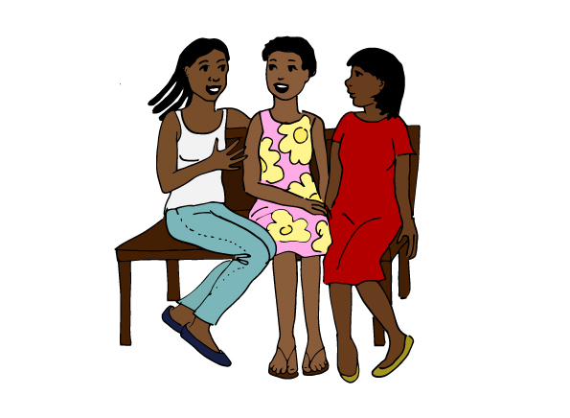
- Encourage the patient to use self-encouragement and positive statements to help motivation (eg ‘I can…’).
FOOD | ADVICE
CarbohydratesCs | Whole meal brown bread, rice, cereal is good, eg 2 slices or fist sized portion per main meal. Avoid eg white bread or sugar
Meat | - Fish, chicken better than red meats such as beef or goat.  - A pack of playing cards sized portion a day. But no bush meat.
Fats | - Reduce total daily fat and especially animal fat and palm oil.  - Use vegetable oil to cook <1 tablespoon/day (1/2 thumb size).  - Grill or boil food; avoid fried food such as ‘chips’, crisps.  - Eat fish and chicken rather than red meat, remove visible fat.
Salt | - Add less salt when cooking (no added salt if also use ‘seasoning’ which includes salt).  - Avoid ready-made or street food as is unhealthy with a lot of fat and salt, home cooked is better.
Fruit and vegetables | - Eat at least 5 apple sized fruit or vegetable portions every day.
Drinks | - Drink water in place of tea with sugar or other sugary drinks.

Encourage rewards for positive changes:
- Encourage them to congratulate themselves with each small change
- Discuss ways to get positive feedback from individuals, community groups
or online groups.
- Discuss what kind of rewards may be most likely to motivate them.

Give this advice but don’t expect the patient to make all these changes at once. Instead aim for one or two changes at each meeting and review goals as they meet each one.

Physical activity

Use an education leaflet (if available) as a prompt.
Key messages:
- Increasing physical activity will help to keep your heart healthy.
- A lack of physical activity will increase your chance of having a stroke, heart attack and dying prematurely.
Advise:
- Daily physical activity for at least 30 minutes that will make them out of breath
- Encourage them to do moderate intensity activity in bouts of:
- 10 minutes 2-3 times a day OR 30 minutes on at least 5 days a week
- Fast walking, jogging or cycling and/or manual work eg farming or gardening.
- Use stairs rather than the lift.
- Minimise the time they spend sitting for extended periods.
- Consider activities that the patient enjoys and how these can be incorporated into their daily routine. Ask if they can make this a family or community activity (for example starting/joining a fitness group). This will make it more fun and motivate.
- Undertake physical activity on at least 2 days a week.
Help the patient make a plan:
- Identify barriers to physical activity and plan ways to overcome them.
- Identify a specific, measurable and realistic goal and discuss a plan to achieve this.
- Ask the patient to identify when, where and how they might achieve their goals.
- Start with simple, achievable goals and increase difficulty at each meeting until the target behaviour is achieved.
- Encourage them to monitor their progress, i.e. keeping an exercise diary.
- Ask the patient to remind themselves of all the reasons they want to increase their physical activity.
- Ask patient to inform family and friends and ask for their support.
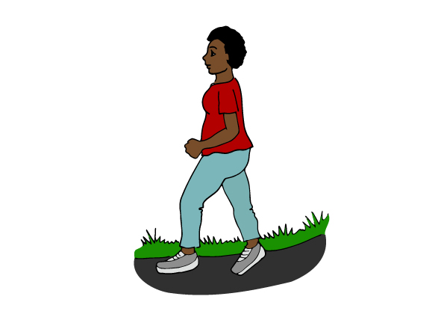
Encourage use of rewards to aid motivation eg every time they do 30 minutes of physical activity they put some money in a jar – and at end of the week they can reward themselves with a treat. Avoid using food as a reward.
- Encourage them to congratulate themselves with each small change
- Discuss ways to get positive feedback from individuals, community or online groups.
- Encourage the patient to use self-encouragement and positive statements to help motivation (e.g. ‘I can…’
- Discuss what kind of rewards may be most likely to motivate them.

Reducing alcohol intake

Use an education leaflet (if available) as a prompt.
Key messages:
- Long-term alcohol intake will cause heart disease, stroke and liver disease.
- If patient has diabetes, alcohol can make them very ill with low blood sugar (especially if on insulin or sulphonylurea tablets).
Advise individuals to drink no more than 3 units per day, which is equal to: 1 bottle of beer, OR 1 glass of grape wine/palm wine, OR 2 shot glasses of spirits.
Help the patient to make a plan:
- Identify barriers to reducing alcohol intake and plan ways to overcome them. This can include identifying stressful or high-risk situations.
- Encourage the patient to consume non-alcoholic drinks instead of alcohol when socialising.
- Identify a specific, realistic goal and discuss a plan to achieve this. Start with simple, achievable goals and increase difficulty at each meeting until the target behaviour is achieved.
- Encourage them to monitor their progress, i.e. keep an alcohol intake diary.
- Ask the patient to remind themselves of all the reasons they want to reduce their alcohol intake.
- Encourage the patient to use self-encouragement and positive statements to help motivation (e.g. ‘I can…’).
- If alcohol intake is excessive, make an appointment with a doctor and tell the patient not to stop alcohol suddenly, as it could make them seriously unwell.
Encourage rewards for positive changes:
- Encourage them to congratulate themselves with each small change.
- Discuss ways to get positive feedback from individuals, community or online groups.
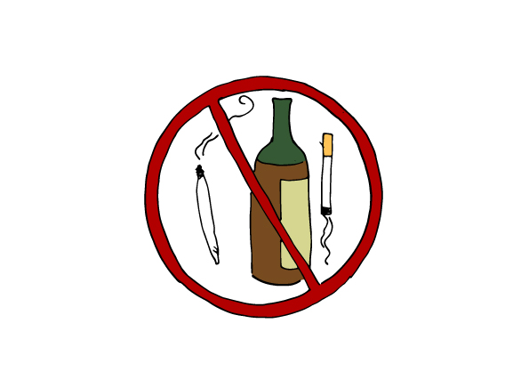
- Encourage patient to put aside money usually spent on alcohol to spend on treating themselves or their families.
- Discuss with the patient what kind of rewards may be most likely to motivate them (e.g. hair or beauty treatments, going out for a meal, or buying new clothes).

Section 3: Counselling on patient’s medical condition

Give information on healthy lifestyles alongside disease-specific advice for the relevant medical condition/s:

Hypertension
Diabetes
Mental Health – Depression/Anxiety
Epilepsy
Asthma
Sickle Cell Disease

Hypertension
Inform patients:
- Hypertension is a life-long condition, but controllable with lifestyle changes and medication.
- Hypertension usually has no symptoms.
- Diabetes and hypertension are linked diseases. Patients with diabetes can develop hypertension and the other way around, especially if overweight.
- A healthy diet, increased physical activity and no smoking are essential.
- Without treatment, there is increased risk of stroke, heart attack, vision problems, disease of the blood vessels, kidney failure and death.
- You can’t give hypertension to others (but relatives/children are at increased risk).

Encourage patients to share the message about healthy eating and increased activity with their relatives, to reduce their risk of hypertension and other diseases.

Remind the patient:
- Of the importance of lifestyle changes to accompany medications.
- Of the name and dosage of each tablet.
- To take tablets as prescribed, at the same time each day.
- Not to take someone else's tablets.
- If they forget to take a tablet, not to take an extra dose next time, instead carry on as normal after the missed dose.
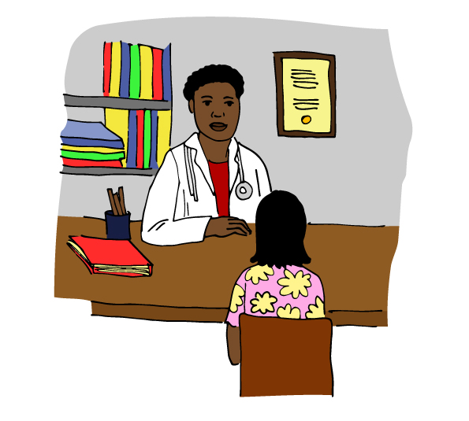
- To only change tablets when the doctor advises them.
- Of side effects and to tell the doctor if they experience any.

Diabetes
Inform patient:
- Diabetes is when the body cannot properly use the foods we eat, especially sugar, due to lack of insulin.
- Treatment is life-long.
- A person cannot give diabetes to another person. However, relatives, particularly their children, are at increased risk and they must take preventive measures
- Blood sugar control, a healthy diet and enough physical activity are essential.
- If blood sugar is not controlled, it can cause blindness, kidney failure, heart disease, strokes, diseases of the blood vessels, impotence, leg ulcers and death.
- Diabetes and hypertension are linked diseases.
- Patients with diabetes can develop hypertension and the other way round, especially if overweight.
- High blood sugars in pregnancy can damage unborn babies.
- Patients with diabetes have a high risk of infection including TB. If they have a productive cough (even if less than 2 weeks) the sputum will need to be checked in the lab – advise them to see a doctor if that happens.
Lifestyle advice
- By eating healthily, losing weight (if you're overweight), you may be able to keep your blood sugar at a safe and healthy level, though you may also need medication as well.
- Give lifestyle advice, as in section 2 of this guide.
Encourage patient to:
- Reduce weight, if overweight.
- Eat a healthy balanced diet.
- Take regular physical activity (30 minutes per day).
- Stop smoking.
- Reduce alcohol intake.
Encourage patients to take control of their diabetes:
- Help them to get the information they need to feel more confident in managing their diabetes.
- Suggest they examine their feet regularly between reviews (or ask someone they know to check them).
- Encourage them to attend appointments or re-arrange them as soon as possible and make a list of points to bring up during their appointments.
- Carry some form of medical identification about their diabetes.
- Ask for help if they are ill, and know the ‘sick day rules’.
- A day before the appointment or the same day if feasible:
- Do a fasting blood sugar test (FBS), i.e. after not eating (and only drinking water) for 8-10 hours, for example in the morning before breakfast (normal is <7mmol) and another sugar test 2 hours after meal (normal <11.1mmol)

Foot care education
- Do not walk with bare feet.
- Make sure shoes fit properly and do not cause shoe bites. Advise to buy footwear in the evening when foot size is biggest.
- Wash and dry your feet regularly.
- Check your feet regularly for any broken skin. If any new broken skin, go to the hospital or other health facility to be seen, even if painless.
- Do not cut calluses or corns – go to the clinic for treatment.
- If you have numbness in feet, be careful near fires and hot water.

Inform patients taking insulin:
- The sites they may choose to inject.
- Inject at 90 degree angle (or at 45 degrees if patient is thin).
- Patients are more likely to gain weight.
- Patients are more likely to get low sugar with insulin - hypoglycaemia or ‘hypos’
- Patients may get swollen ankles.
- It is important to take insulin even if unwell or not eating, but the dose may need to be altered.
- Educate on the symptoms of hypoglycaemia as below, recognise early and take action.
- For people with home glucose monitors, they should be encouraged to keep a log to guide the clinician whenever they visit the health facility.
- Eat regular meals that are similar each day to avoid the risk of hypos

Explain about hypoglycaemia
Risk of hypoglycaemia (too low blood sugar) if they are on insulin or oral hypoglycaemic drugs (except metformin), especially if:
- Drinking alcohol.
- Missed, small or delayed meals.
- Vigorous activity.
Symptoms of hypoglycaemia:
- headache | - hunger
- dizziness | - irritability
- anxiety | - cold sweat (moist skin)
- weakness/shakiness | - confusion/loss of consciousness
- fast heartbeat

If alert: Drink a sugary drink such as coke, eat a sweet or a tablespoon of sugar/honey (placed under the tongue), and then a snack, e.g. bread.
If not alert/unconscious: Tell family/friends to seek medical help immediately.

- Identify cause of the hypoglycaemia to avoid future occurrence.

Depression and/or Anxiety

Help the patient choose a family member or a reliable friend as a treatment supporter. Ask the patient, the accompanying relative or/and the treatment supporter to attend the clinic’s health education.

Explain to the patient and accompanying family member or treatment supporter:

- Depression/anxiety are very common problems that can happen to anybody. They often, but not always, co-exist.
- Effective treatment is possible.
- It tends to take a few weeks before treatment reduces the depression.
- Adherence to any prescribed treatment is important, and the family and treatment supporter need to ensure that the patient is taking their medicines.
- Do not stop medications suddenly as this can cause withdrawal. See a doctor who can help you decrease the dose gradually if necessary.
- Continue, as far as possible, activities that used to be interesting or gave pleasure, even if they do not currently seem interesting, give pleasure or cause anxiety.
- Regular physical and social activity can help the patient become better, e.g. going to church/mosque, party, visiting friends.
- How to recognise thoughts of self-harm or suicide and to immediately come back for help.
- How to recognise paranoia, delusions, or hallucinations, which are symptoms of more serious mental health problems and to come back for help if that happens.
- To be active and eat healthy foods.
- Not to self-medicate or try and suppress symptoms with drugs or alcohol.

Relaxation exercises that may help:
- Deep slow breathing (about 4-6/min). Repeat several times a day and whenever they feel anxious.
- Practice breathing in for 3 seconds, hold for 3 seconds and breath out for 3 seconds. Do this with them.
- Practice tensing and relaxing muscles so they can feel the difference between tension and relaxation and get them to practice relaxation.
Discuss with the patient and family member supporters (if the patient consents to this):
- Their understanding of the cause of their problems.
- Current psychosocial stressors, e.g. bereavement, work, relationship or family stress and help the patient to solve the problem/ develop ways of improving their problem.
- Supportive family members and involvement in their treatment if appropriate.
- Prior social activities (e.g. family gatherings, outings with friends, religious activities) and encourage patient to start attending these again.

Epilepsy
Explain to the patient and family:
- Epilepsy is not contagious - a person cannot pass epilepsy on to another person. It is not due to ‘demon’ possession.
- Epilepsy is a chronic condition, but seizures can be controlled in most patients with tablets.
- People with epilepsy can lead normal lives.
- Parents should not remove children with epilepsy from school.
- People with epilepsy can work in most jobs, but should avoid working at heights and with heavy machinery.
- People with epilepsy should not do any of the following:
- Drive unless they have been seizure free for 1 year.
- Swim alone.
- Cook by open fire alone.
- Drink alcohol.
- The importance of taking tablets every day and seizures may worsen if medication stops.
- The importance of family support; assign a treatment supporter.
- If they know a seizure is coming to lie down somewhere safe to protect them from falling. Learn any triggers (e.g. flashing lights) and avoid them.
- Children and adults can be diagnosed with epilepsy.
- Women seeking to become pregnant should consult a doctor to first control seizures and start folate, and vitamin K (last month of pregnancy).
- Patients on combination of anti-epileptic drugs, anti-retroviral or TB therapy, etc. drugs, should consult a doctor about drug interactions.
Remind the patient:
- Of name and dosage of each tablet.
- To take tablets as prescribed, at the same time each day.
- Not to take someone else's tablets.
- If they forget to take a tablet, not to take an extra dose next time, instead carry on as normal after the missed dose.
- Only change tablets when the health worker advises them to.
- Of side effects and to tell the health worker if they experience any.
- To bring pills and patients notes at every clinic appointment.

Asthma
Explain to the patient and family:
- The importance of taking medications as directed to improve quality of life and reduce the chance of exacerbations.
- The difference between poor asthma control and good asthma control.
- Good asthma control is:
- No or minimal limitation of daily activities.
- Needing salbutamol no more than 3 times a week to control symptoms.
- Daytime asthma symptoms 2 times a week or less.
- Night time asthma symptoms two times per month or less.
- No severe exacerbation (i.e. requiring oral steroids or admission to hospital) within a month.
- A peak expiratory flow rate (PEFR) above 80% predicted (see below).
- Importance of attending regular review appointments (unless stable) to manage asthma control.
- If symptoms are getting worse, or remain uncontrolled, return to the doctor more frequently.
- Importance of smoking cessation.
- The symptoms of an acute exacerbation (wheeze, difficulty breathing or speaking in sentences), don’t wait at home, get to a health facility immediately.
- How to double up the salbutamol and steroid inhaler doses in an exacerbation.
- If exercise-induced asthma, take salbutamol before exercise.
- How to use an inhaler
- How to make and use a spacer (for use particularly by younger children).
- How to use and read a peak flow meter.
Explain and measure peak flow
The peak flow meter gives a reading that is measurement of how much the patient can blow out of their lungs in one breath (PEFR). However, it is not as accurate as spirometry.
There are guidelines for the “normal” values, which you can use to compare against the values your patient is able to achieve.
It is better to record the patient’s best PEFR, taken when not unwell/wheezy, and then compare their existing PEFR with their best.
You will find the typical PEFR levels by age and sex in the clinical guide.

How to measure PEFR:
- Connect a clean mouthpiece.
- Ensure the marker is set to zero.
- Stand up or sit upright.
- Take as deep a breath in as you can and hold it.
- Place the mouthpiece in your mouth and form as tight a seal as possible around it with your lips (you can still breathe through the mouthpiece).
- Breathe out as quickly and as hard as you can.
- Observe and record the reading.
- Repeat the process 3 times and record the highest reading.
- Note in a diary the reading to allow comparison with readings on other days.
Once you have discussed the process with the patient, you should show the patient how to perform the measurement. Do this by measuring your own PEFR. Do not share mouthpieces as there is a risk of infection. Ask the patient to keep their mouthpiece safe.
Once the technique has been demonstrated, ask the patient to show you how they would perform the measurement themselves. Make sure they are doing it correctly, and correct any mistakes they might be making.
Ask patient and relative if any questions or concerns about asthma or PEFR measurement.
Record on chronic disease card the likely diagnosis, e.g. asthma.
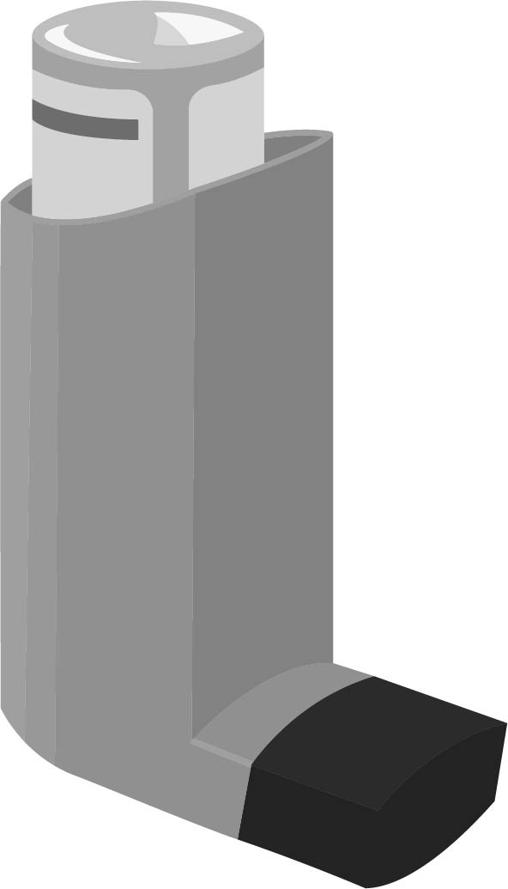

How to use an inhaler

Using an inhaler is the most common way of taking asthma and COPD medicines.
Show and check how to use an inhaler both in the initial consultation and also in subsequent consultations.
Explain the following 8 steps to the patient for proper use of inhalers:
- Remove cap and hold inhaler upright then shake well
- Breathe out gently and put mouthpiece between teeth without biting and make a seal with lips.
- Start to breathe in slowly through mouth and at the same time press down firmly on canister.
- Continue to breathe in slowly and deeply as you can and then hold breath for about 10 seconds.
- While holding breath, remove inhaler from mouth.
- Breathe out gently away from mouthpiece.
- If an extra dose is needed, wait 1 minute and repeat steps 2 to 6.
- Replace cap.
How to make a spacer out of a plastic bottle
Patients, especially younger children, can find it difficult to use metered dose inhalers. Spacers mean that people do not need to coordinate taking a breath in whilst pressing the inhaler.

To make a spacer out of a bottle, use a soldering iron, a piece of hot metal or a candle to make a hole at the bottom of the bottle as shown below. The hole should be nearly the size of the inhaler. When the plastic is hot, the inhaler can be pressed in to make a hole of the correct size.

How to use a spacer
- Remove inhaler cap and hold upright then shake well.
- Place the inhaler into the hole in the side of the spacer.
- Breathe out gently and put mouthpiece between teeth without biting and make a seal with lips.
- Put one puff of your inhaler into the spacer and breathe in normally but deeply through the mouthpiece.
- It is best to take at least 3 deeply held breaths for each puff of your inhaler.
- If you find it difficult to take deep breaths, breathe in and out of the mouthpiece several times after each puff of the inhaler.
- Repeat the step above for each dose/puff needed.

Wash your spacer once a month - leave it to drip-dry as this helps to prevent the medicines sticking to the sides. Spacers should be replaced at least every year.

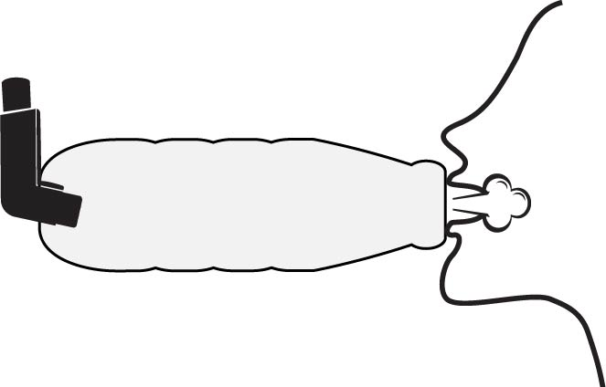

Sickle cell disease
Explain to the patient and family:
- It is a serious inherited blood disorder where the red blood cells, which carry oxygen around the body, develop abnormally.
- It is caused by a mutation (an abnormal change) in the gene that instructs the body to produce haemoglobin.
- To get sickle cell anaemia you have to inherit the defective gene from both parents.
- Pain is a defining feature which is often unpredictable, recurrent, persistent and occurs throughout life.
- Painful swelling of the hands and feet can occur from 6 months of age.
- Management is possible and involves maintaining a steady state of health.
- Patients, family and treatment supporters can learn to identify and prevent sickle cell crisis.
- The importance of treating crises promptly and effectively to reduce serious complications including stroke, increased vulnerability to infection, acute chest syndrome and pulmonary hypertension.

Counsel on the pre-disposing factors for sickle cell crisis:
- Exposure to cold/drenched by rain.
- Physical exertion.
- Dehydration.
- Injury (including surgical injury).
- Psychological stress.
- Infections/infestations.
- Some drugs.

Encourage the patient to:
- Have a healthy lifestyle and a positive self-image.
- Consider sickle cell anaemia as a manageable problem that they can have
control over.
- Drink plenty of water to avoid dehydration particularly during hot weather (dehydration increases the likelihood of sickle cells forming).
- Take only gentle exercise regularly.
- Eat a healthy balanced diet to support immune system.
- Learn relaxation techniques to avoid stress.
- Talk problems over with family and friends or a support group.
- Encourage individuals with sickle cell trait to avoid having children with someone else with the sickle cell trait as on average 1 in 4 of their children may have
sickle cell disease.
- Avoid misusing illegal drugs, limit consumption of alcohol and avoid smoking.

