Health education leaflet

The Health education leaflet should be given to all those who are diagnosed with pre-diabetes, diabetes, hypertension and CVD, as well as those who are at high risk of CVD (if >50 years, overweight, smoker).

The leaflet provides the patient with information about the link between behaviour and lifestyle, and the possible consequences of their behaviour. It is not designed to facilitate behaviour change.

If a patient decides to change their behaviour, we advise discussing this with them and then referring them on to a health educator where available.

The ’tri-fold’ leaflet can be printed double-sided and folded into three parts as shown below.

NOTE: The text that appears in blue within the leaflet highlights those points which are most likely to need adapting to your country context. If you do adapt the leaflet, we recommend adding pictures that emphasise key messages and are relevant to your country context.

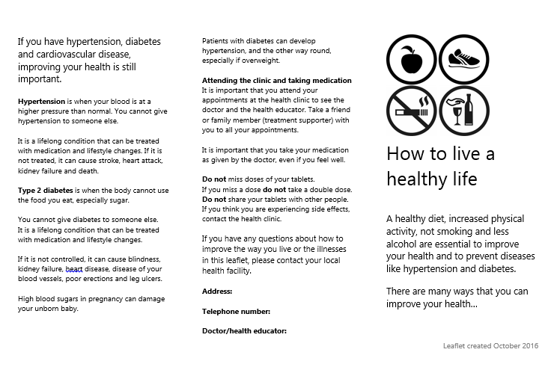
Front page
Inner page
Back page

If you have hypertension, diabetes and cardiovascular disease, improving your health is still important.

Hypertension is when your blood is at a higher pressure than normal. You cannot give hypertension to someone else.

It is a lifelong condition that can be treated with medication and lifestyle changes. If it is not treated, it can cause stroke, heart attack, kidney failure and death.

Type 2 diabetes is when the body cannot use the food you eat, especially sugar.

You cannot give diabetes to someone else.
It is a lifelong condition that can be treated with medication and lifestyle changes.

If it is not controlled, it can cause blindness, kidney failure, heart disease, disease of your blood vessels, poor erections and leg ulcers.

High blood sugars in pregnancy can damage your unborn baby.

Patients with diabetes can develop hypertension, and the other way round, especially if overweight.
Attending the clinic and taking medication
It is important that you attend your appointments at the health clinic to see the doctor and the health educator. Take a friend or family member (treatment supporter) with you to all your appointments.

It is important that you take your medication as given by the doctor, even if you feel well.

- Do not miss doses of your tablets.
- If you miss a dose do not take a double dose.
- Do not share your tablets with other people.
If you think you are experiencing side effects, contact the health clinic.

If you have any questions about how to improve the way you live or the illnesses in this leaflet, please contact your local health facility.

Address:

Telephone number:

Doctor/health educator:
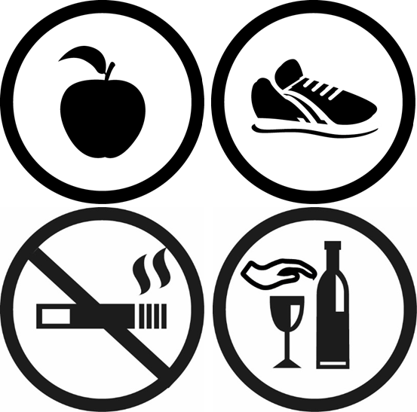

How to live a healthy life

A healthy diet, increased physical activity, not smoking and less alcohol are essential to improve your health and to prevent diseases like hypertension and diabetes.

There are many ways that you can improve your health…

Stopping smoking
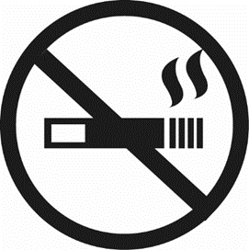
Giving up smoking is the most important thing you can do to protect your heart and health.

If you smoke, you are more likely to have heart attacks, strokes, kidney disease, peripheral vascular disease and poor erections. Other forms of tobacco are also bad for your health. Smoking in the home can be harmful to your family.

If you want to quit smoking, it is important that you have support from your doctor and family.

Eating healthy food
Improving your diet can improve your health. Eating unhealthy food can cause heart disease and strokes. Try to:
- eat locally-available healthy food
- eat 3 regularly-spaced meals per day
- drink water instead of tea or sugary drinks
- eat less fat, eg ghee

- use vegetable oil for cooking, less than 1 tablespoon each day
- grill or boil food; avoid fried food
- eat fish and chicken rather than red meat; remove visible fat
- eat at least 5 fruit or vegetables every day
- add less salt when cooking
- avoid ready-made or street food; home cooked is better

Being active

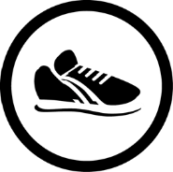
Increasing physical activity will help keep your heart healthy.
A lack of physical activity increases your chance of having a stroke, heart attack and dying.

Try to do 30 minutes of activity each day that makes you out of breath, for instance:

- manual work, eg farming
- fast walking
- cycling
- use stairs rather than the lift
- sports

Reducing alcohol intake
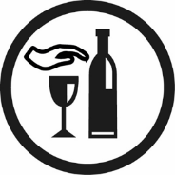
Reducing the amount of
alcohol you drink will reduce your chance of developing heart disease.
Long-term alcohol intake will cause heart disease, stroke and liver disease.

It is important to try to drink less than 3 units each day (1.5 pints of beer, 1 large glass of wine, or 75ml of spirits).

If you have diabetes, alcohol can make you very ill with low blood sugar (especially if you are on insulin or sulphonylurea tablets).

If you want to change any of the behaviours discussed then please talk to your doctor.

